# Lab 10: Creating a Form to Edit Your Data

## Objectives

*  Create a form component
*  Render the form component

## Steps

### Create a form component

1. Add the following CSS style to to set the width of the form.

src\index.css

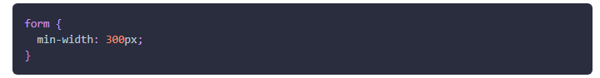

1. Create the file src\projects\ProjectForm.js.
2. Implement a ProjectForm **function** component that meets the following specifications:

* Paste the HTML below into the render method of the ProjectForm and use your editor and the link below to identify the changes needed to the HTML to make it JSX.

[DOM Element vs JSX Element Differences](https://reactjs.org/docs/dom-elements.html" \l "differences-in-attributes" \t "https://handsonreact.com/docs/labs/js/_blank)

We will pass the project object as a prop in a later lab so you just need to render the HTML from the previous step as JSX.

### Solution

#### src\projects\ProjectForm.js

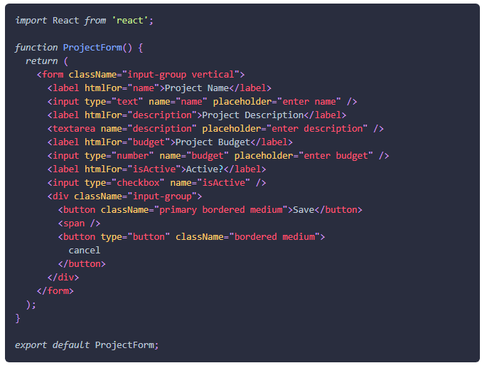

### Render the form component

1. Open the file src\projects\ProjectList.js.
2. Render the ProjectForm component below the ProjectCard.

#### src\projects\ProjectList.js

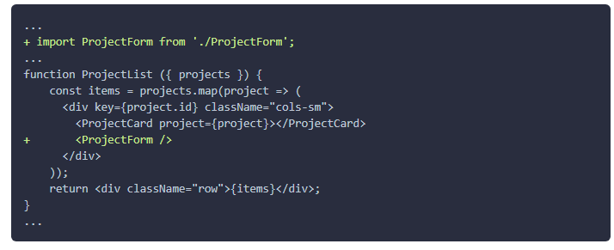

1. Verify a form renders under each card in the application. Note, you may need to reload the application a few times to see the changes on this step.

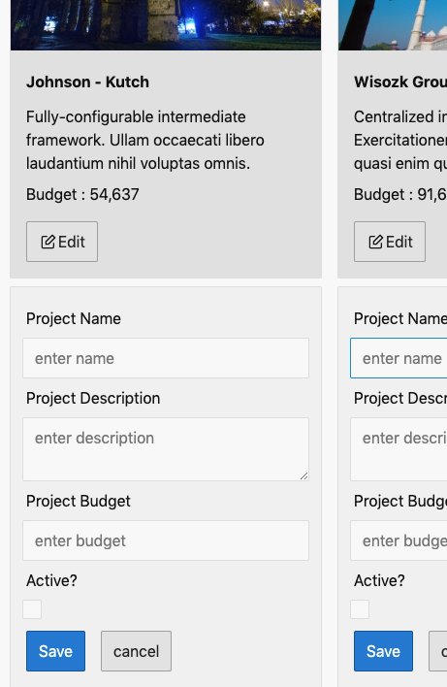

### ✔ You have completed Lab 10